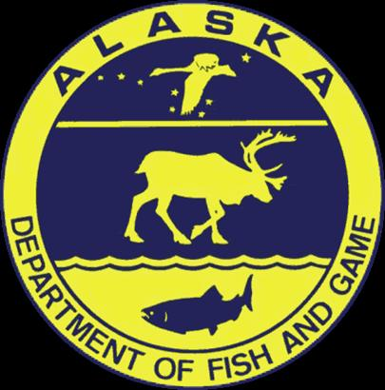

2015: Outlook and Forecast for Chinook Salmon Timing
Lower Yukon River (Area Y-1), June 1, 2015
Outlook
The outlook for Yukon River Chinook salmon timing in 2015 calls for an average to slightly late run this year. The first significant pulse (15% point) of Chinook is expected to cross the delta around June 15, which is one day later than the long-term average 1961 – 2014. The half-way point (50%) in the run will be reached about June 23, which is two days later than the long term average. While the April mean air temperature at Nome this year (-5.89 C) was slightly warmer than average, the average sea surface temperatures (-1.69 C) in waters adjacent to the delta were slightly colder than average, and the average spring (March 20 – May 31) sea ice concentrations (55.7%) in waters between the delta and St. Lawrence Island (Shpanberg Strait) were close to average.

Forecast 2015

Based on the relationship between the dates of the three percentiles (15%, 25%, 50%) and the sea ice concentrations and the air and sea surface temperatures, the predicted dates of the three percentiles are June 15 (15%), June 17 (25%), and June 23 (50%) in District Y-1 of the Lower Yukon River
Predicted % Points 2015
Fifteen | June 15
Twenty-five | June 17
Fifty | June 23

Updates will be issued as the season progresses whenever the run timing appears to be deviating from the forecast. For updates, details of the statistical analysis, and more information on this year’s environmental data, please go to http://www.aoos.org/2015-yukon-chinook-forecasting/

Credits
Outlook prepared by Phil Mundy phil.mundy@noaa.gov. Forecast and statistical analysis by Bryce Mecum bdmecum@alaska.edu. Data management and web page support by Will Koeppen will@axiomalaska.com . Web content and web support by Darcy Dugan dugan@aoos.org. Yukon Chinook salmon data, peer review and management agency coordination by Stephanie Schmidt stephanie.schmidt@alaska.gov. Financial and material supports were provided by the Alaska Ocean Observing System, NOAA National Marine Fisheries Service and the Alaska Department of Fish and Game.

