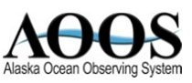
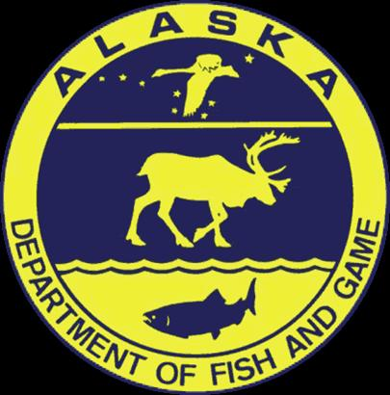
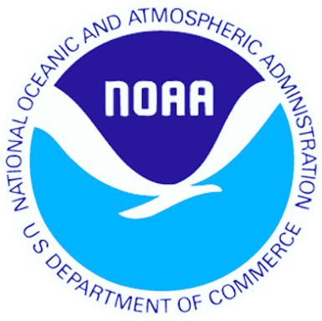

2016: Final Outlook and Forecast for Chinook Salmon Timing
Lower Yukon River (Area Y-1), June 1, 2016

Outlook
The final outlook for Yukon River Chinook salmon timing in 2016 calls for an early to almost average run this year. The first significant pulse (15% point) of Chinook is expected to cross the delta around June 9, which is five days earlier than the long-term average 1961 – 2015. The half-way point (50%) in the run will be reached about June 19, which is two days earlier than the long term average. The April mean air temperature at Nome this year (1.3 C) was the second warmest since record keeping began in 1907. In keeping with the very warm early spring conditions the spring (March 19 – May 31) sea ice concentrations (41.6%) were lower than average in the waters between the delta and St. Lawrence Island (Shpanberg Strait). Even so, the run forecast stopped short of being as early as the air temperatures and ice concentrations alone would indicate because later spring conditions in marine areas just off the delta were just about average, based on average sea surface temperatures (-0.6 C).

Forecast 2016
Based on the relationship between the dates of the three percentiles (15%, 25%, 50%) and the sea ice concentrations and the air and sea surface temperatures, the predicted dates of the three percentiles are June 9 (15%), June 12 (25%), and June 19 (50%) in District Y-1 of the Lower Yukon River
Predicted % Points 2016
Fifteen | June 9
Twenty-five | June 12
Fifty | June 19

The run can be tracked on the project web site where estimated daily percentages of the run are compared to results of the 2016 Lower Yukon Test Fishery and past years test fisheries. If the timing model is not matching the results of the test fishery as the season progresses, the forecast dates will be updated and posted on the web site.

Credits
Outlook prepared by Phil Mundy phil.mundy@noaa.gov. Statistical analysis by Bryce Mecum bdmecum@alaska.edu. Data management and web page support by Will Koeppen will@axiomalaska.com. Web support also provided by Holly Kent kent@aoos.org. Yukon Chinook in-season salmon data and management agency coordination by Holly Carroll holly.carroll@alaska.gov and Sabrina Garcia Sabrina.garcia@alaska.gov. Financial and material supports were provided by the Alaska Ocean Observing System, NOAA National Marine Fisheries Service and the Alaska Department of Fish and Game.

